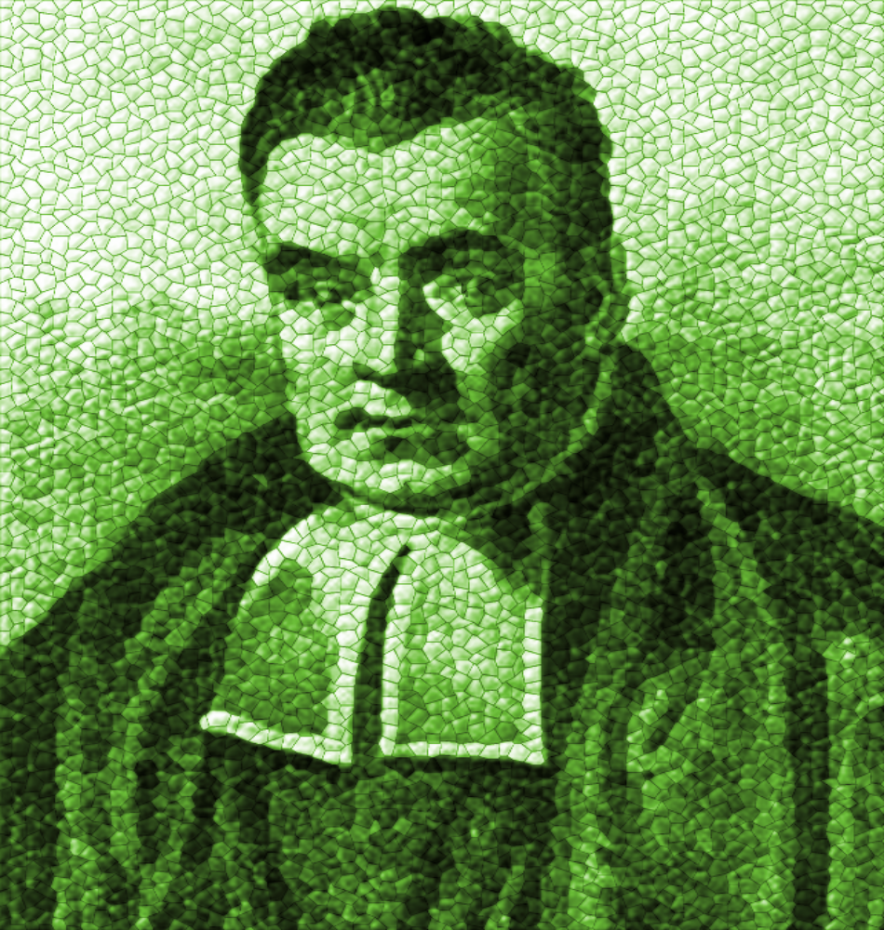


“God always does that which is right and fit, and that all his moral attributes, [namely] justice, truth, faithfulness, mercy, patience, [etc.] are but so many different modifications of rectitude.”

“God always does that which is right and fit, and that all his moral attributes, [namely] justice, truth, faithfulness, mercy, patience, [etc.] are but so many different modifications of rectitude.”

homas Baye
Bayes Theorem
Baysian Inference Baysian Statistics

S
T

The Reverend

“The more I study nature, the more I stand amazed at the work of the Creator. Into his tiniest creatures, God has placed extraordinary properties ...”
"I am a Christian...I believe... only and alone in the service of Jesus Christ...In Him is all refuge, all solace."


